TITLE: NEWTON-RAPHSON METHOD FOR FINDING ROOTS OF EQUATIONS
Definition:
The Newton-Raphson method is an iterative numerical technique used to find approximate roots of a real-valued function. It uses the function and its derivative to rapidly converge to a solution, starting from an initial guess.
Algorithm:
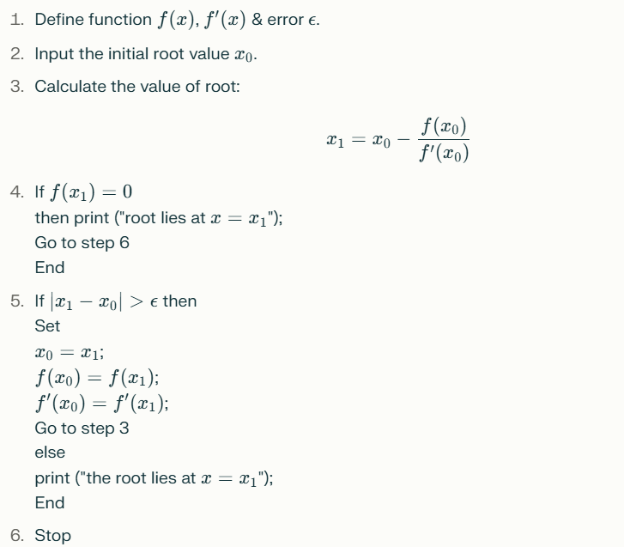

Flowchart:
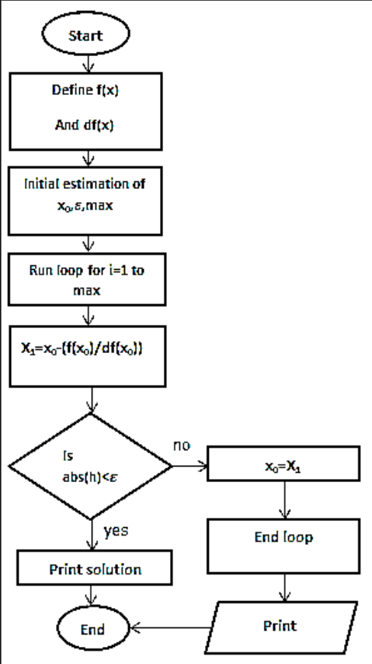
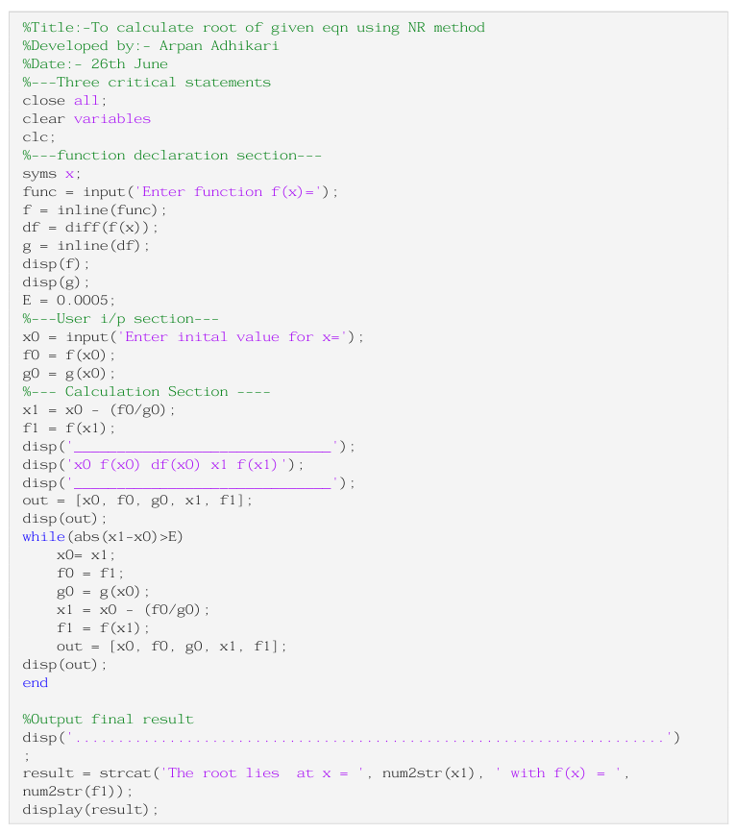

Output:
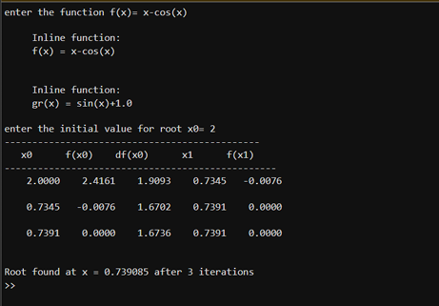
Conclusion:
The Newton-Raphson method is a powerful and efficient tool for finding the roots of equations.

TITLE: LAGRANGE INTERPOLATION METHOD
Definition:
Lagrange interpolation is a numerical technique used to estimate the value of a function at a desired point, given a set of known discrete data points. It constructs a polynomial that passes exactly through all the provided data points, allowing for the interpolation of intermediate values.

Algorithm:
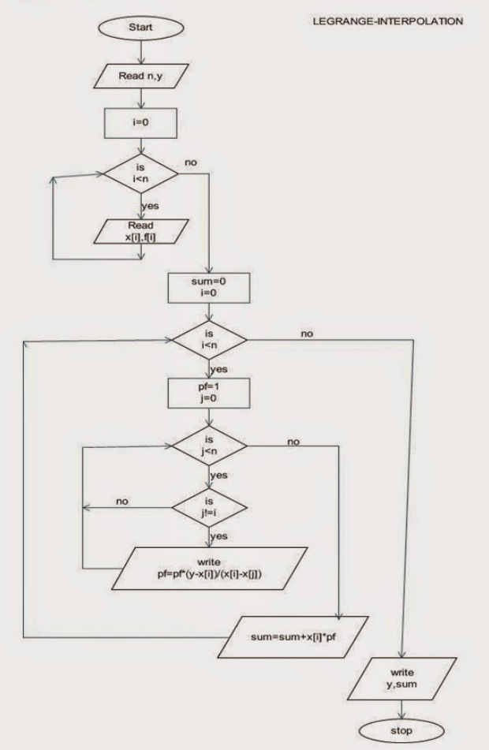
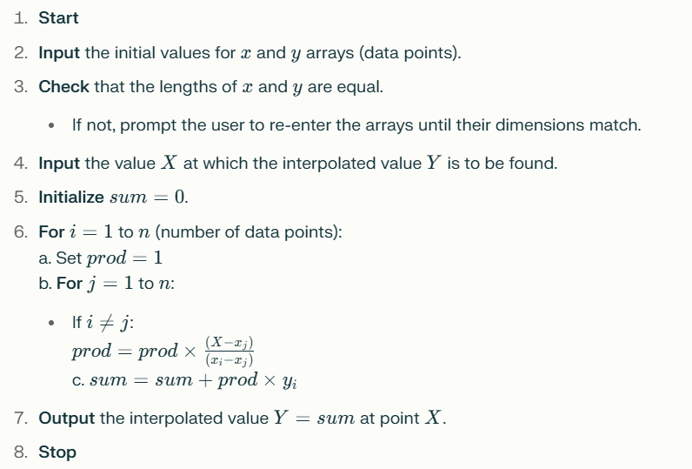

Flow Chart:

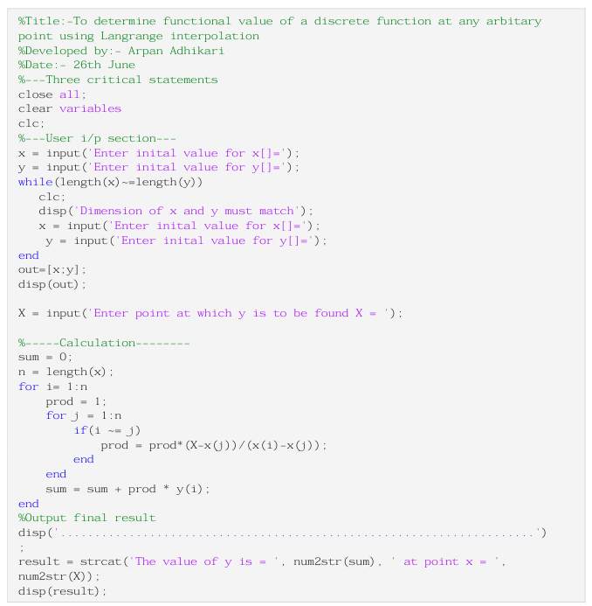
Output:
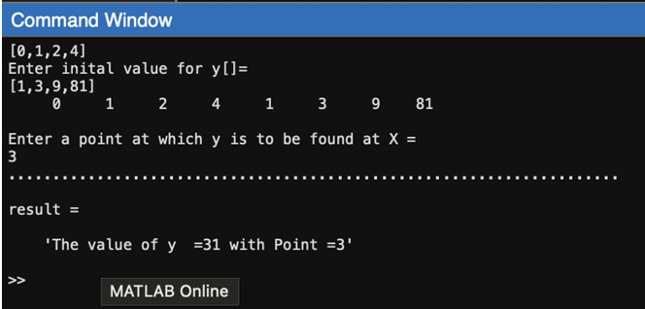

Conclusion:
Lagrange interpolation provides a straightforward way to estimate the value of a function at any point within the range of given data. The method is exact for the provided data points and is widely used in engineering and science for curve fitting and data analysis.

